Unit Materials
and Supplemental Readings

HISTORY 101
TEST III

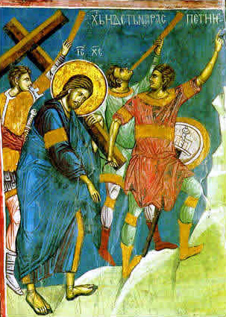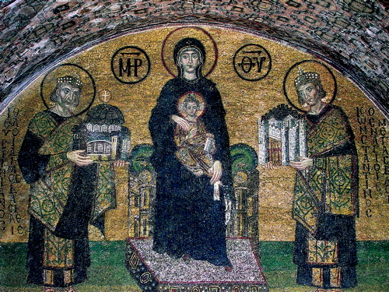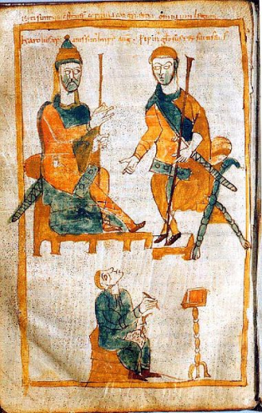

Empires of Monotheism

Mr. Tom Richey,
Instructor

HIS 101 TEST III STUDY GUIDE

Christianity

Jesus
Pilate
Paul
Nero
Justin
Galilee

Antonines (Five Good Emperors + Commodus)

What made the Antonines unique? What did they do to bring in a period of stability in the Roman Empire?

Trajan
Hadrian
Marcus Aurelius
Commodus

Eastern Empire

Constantine
Edict of Milan
Julian
Against the Galileans
Theodosius
Ambrose
Justinian – might be the subject of a multiple choice question

Islam: People and Terms

Muhammad
Bedouin
Mecca
Medina
Kaaba
Black Stone – know origins
Five Pillars – know Ramadan and Hajj by proper names – English is fine for the rest

Europe After the Fall of Rome

Charlemagne
Leo III (Pope)
Franks
Holy Roman Empire

Religious Controversies and the Crusades

filioque
bull
Pilgrim
Knights Templar
Seljuk Turks
Richard the Lionheart*
Venetians*
Sack of Constantinople*

* When appropriate, make sure that you know which Crusade is associated with particular people and/or events

ESSAY

Write a clear, multi-paragraph, thesis driven essay - supplemented with historical evidence - in response to the following prompt:

Explain how the Roman government's attitude toward Christianity (i.e., Christianity's legal status) changed over time from the period from 30 - 395 A.D.

You should include references to several of the following historical figures in your essay:

Paul
Nero
Trajan
Justin Martyr
Diocletian
Constantine
Julian
Theodosius

You may use the rest of this page for brainstorming, thesis construction, and outlining. Remember, your thesis and essay should emphasize change over time.

Document 3.1

From The Acts of the Apostles, Chapter 16 (NIV)

Paul and Silas in Prison
¹⁶Once when we were going to the place of prayer, we were met by a slave girl who had a spirit by which she predicted the future. She earned a great deal of money for her owners by fortune-telling. ¹⁷This girl followed Paul and the rest of us, shouting, "These men are servants of the Most High God, who are telling you the way to be saved." ¹⁸She kept this up for many days. Finally Paul became so troubled that he turned around and said to the spirit, "In the name of Jesus Christ I command you to come out of her!" At that moment the spirit left her.
¹⁹When the owners of the slave girl realized that their hope of making money was gone, they seized Paul and Silas and dragged them into the marketplace to face the authorities. ²⁰They brought them before the magistrates and said, "These men are Jews, and are throwing our city into an uproar ²¹by advocating customs unlawful for us Romans to accept or practice."
²²The crowd joined in the attack against Paul and Silas, and the magistrates ordered them to be stripped and beaten. ²³After they had been severely flogged, they were thrown into prison, and the jailer was commanded to guard them carefully. ²⁴Upon receiving such orders, he put them in the inner cell and fastened their feet in the stocks.
²⁵About midnight Paul and Silas were praying and singing hymns to God, and the other prisoners were listening to them. ²⁶Suddenly there was such a violent earthquake that the foundations of the prison were shaken. At once all the prison doors flew open, and everybody's chains came loose. ²⁷The jailer woke up, and when he saw the prison doors open, he drew his sword and was about to kill himself because he thought the prisoners had escaped. ²⁸But Paul shouted, "Don't harm yourself! We are all here!"
²⁹The jailer called for lights, rushed in and fell trembling before Paul and Silas. ³⁰He then brought them out and asked, "Sirs, what must I do to be saved?"
³¹They replied, "Believe in the Lord Jesus, and you will be saved—you and your household." ³²Then they spoke the word of the Lord to him and to all the others in his house. ³³At that hour of the night the jailer took them and washed their wounds; then immediately he and all his family were baptized. ³⁴The jailer brought them into his house and set a meal before them; he was filled with joy because he had come to believe in God—he and his whole family.
³⁵When it was daylight, the magistrates sent their officers to the jailer with the order: "Release those men." ³⁶The jailer told Paul, "The magistrates have ordered that you and Silas be released. Now you can leave. Go in peace."
³⁷But Paul said to the officers: "They beat us publicly without a trial, even though we are Roman citizens, and threw us into prison. And now do they want to get rid of us quietly? No! Let them come themselves and escort us out."
³⁸The officers reported this to the magistrates, and when they heard that Paul and Silas were Roman citizens, they were alarmed. ³⁹They came to appease them and escorted them from the prison, requesting them to leave the city.
QUESTIONS TO CONSIDER:
- What happened to Paul and Silas when they caused a disturbance?
- Why were the magistrates afraid of Paul and Silas the following morning?

Document 3.2

Comparative Timeline
The Roman Empire and Early Christianity

ROME | DATE | CHRISTIANITY
Julius Caesar Assassinated  Augustus assumes the principate  Death of Augustus  Principate of Tiberius  Principate of Gaius “Caligula”  Principate of Claudius  Principate of Nero  Great Fire of Rome  Beginning of Roman persecution of Christians  “Year of the Four Emperors”  First Jewish-Roman War  Temple of Jerusalem Destroyed | 44 B.C.  27 B.C.  c. 7 B.C. – 2 A.D.  12-15 A.D.  14-37 A.D.  c. 30 A.D.  c. 33 A.D.  37-41 A.D.  41-54 A.D.  54-68 A.D.  58 A.D.  60 A.D.  64 A.D.  c. 64-65 A.D.  68 A.D.  70 A.D. | Jesus born in Judea  Paul of Tarsus educated as a rabbi in Jerusalem  Jesus crucified in Judea  Peter preaches Jesus’ Resurrection  Paul of Tarsus converts to Christianity – begins mission work  Paul arrested in Judea  Paul appeals his case to Caesar  Peter and Paul executed in Rome

Document 3.#

Correspondence between Pliny the Younger and Trajan on the Christians
From Pliny the Younger, Letters 10.96-97
Early Christian Writings: http://www.earlychristianwritings.com/text/pliny.html
Historical Background:
Pliny the Younger was governor of Pontus and Bithynia from 111-113 CE. We have a whole set of exchanges of his letters with the emperor Trajan on a variety of administrative political matters. These two letters are the most famous, in which Pliny the Younger encounters Christianity for the first time.

Pliny the Younger to the Emperor Trajan
It is my practice, my lord, to refer to you all matters concerning which I am in doubt. For who can better give guidance to my hesitation or inform my ignorance? I have never participated in trials of Christians. I therefore do not know what offenses it is the practice to punish or investigate, and to what extent. And I have been not a little hesitant as to whether there should be any distinction on account of age or no difference between the very young and the more mature; whether pardon is to be granted for repentance, or, if a man has once been a Christian, it does him no good to have ceased to be one; whether the name itself, even without offenses, or only the offenses associated with the name are to be punished.
Meanwhile, in the case of those who were denounced to me as Christians, I have observed the following procedure: I interrogated these as to whether they were Christians; those who confessed I interrogated a second and a third time, threatening them with punishment; those who persisted I ordered executed. For I had no doubt that, whatever the nature of their creed, stubbornness and inflexible obstinacy surely deserve to be punished. There were others possessed of the same folly; but because they were Roman citizens, I signed an order for them to be transferred to Rome.
Soon accusations spread, as usually happens, because of the proceedings going on, and several incidents occurred. An anonymous document was published containing the names of many persons. Those who denied that they were or had been Christians, when they invoked the gods in words dictated by me, offered prayer with incense and wine to your image, which I had ordered to be brought for this purpose together with statues of the gods, and moreover cursed Christ--none of which those who are really Christians, it is said, can be forced to do--these I thought should be discharged. Others named by the informer declared that they were Christians, but then denied it, asserting that they had been but had ceased to be, some three years before, others many years, some as much as twenty-five years. They all worshipped your image and the statues of the gods, and cursed Christ.
They asserted, however, that the sum and substance of their fault or error had been that they were accustomed to meet on a fixed day before dawn and sing responsively a hymn to Christ as to a god, and to bind themselves by oath, not to some crime, but not to commit fraud, theft, or adultery, not falsify their trust, nor to refuse to return a trust when called upon to do so. When this was over, it was their custom to depart and to assemble again to partake of food--but ordinary and innocent food. Even this, they affirmed, they had ceased to do after my edict by which, in accordance with your instructions, I had forbidden political associations. Accordingly, I judged it all the more necessary to find out what the truth was by torturing two female slaves who were called deaconesses. But I discovered nothing else but depraved, excessive superstition.
I therefore postponed the investigation and hastened to consult you. For the matter seemed to me to warrant consulting you, especially because of the number involved. For many persons of every age, every rank, and also of both sexes are and will be endangered. For the contagion of this superstition has spread not only to the cities but also to the villages and farms. But it seems possible to check and cure it. It is certainly quite clear that the temples, which had been almost deserted, have begun to be frequented, that the established religious rites, long neglected, are being resumed, and that from everywhere sacrificial animals are coming, for which until now very few purchasers could be found. Hence it is easy to imagine what a multitude of people can be reformed if an opportunity for repentance is afforded.

Trajan to Pliny the Younger
You observed proper procedure, my dear Pliny, in sifting the cases of those who had been denounced to you as Christians. For it is not possible to lay down any general rule to serve as a kind of fixed standard. They are not to be sought out; if they are denounced and proved guilty, they are to be punished, with this reservation, that whoever denies that he is a Christian and really proves it--that is, by worshiping our gods--even though he was under suspicion in the past, shall obtain pardon through repentance. But anonymously posted accusations ought to have no place in any prosecution. For this is both a dangerous kind of precedent and out of keeping with the spirit of our age.

Questions to Consider:

- What does Pliny’s letter to Trajan suggest about attitudes toward Christians in the second century?

- To what extent was there an ambivalence about the extent to which Christians posed a danger to society?

- What policy did Trajan advocate for dealing with Christians? To what extent did this policy promote toleration?

- In what ways does Trajan’s suggested policy foreshadow the U.S. Bill of Rights?

- What do you think Trajan means by “the spirit of our age”?

Document 3.#

Julian the Apostate, Against the Galileans
excerpted from Cyril of Alexandria, Contra Julianum
The Tertullian Project: http://www.tertullian.org/fathers/julian_apostate_galileans_1_text.htm

It is, I think, expedient to set forth to all mankind the reasons by which I was convinced that the fabrication of the Galileans is a fiction of men composed by wickedness. Though it has in it nothing divine, by making full use of that part of the soul which loves fable and is childish and foolish, it has induced men to believe that the monstrous tale is truth. Now since I intend to treat of all their first dogmas, as they call them, I wish to say in the first place that if my readers desire to try to refute me they must proceed as if they were in a court of law and not drag in irrelevant matter, or, as the saying is, bring counter-charges until they have defended their own views. For thus it will be better and clearer if, when they wish to censure any views of mine, they undertake that as a separate task, but when they are defending themselves against my censure, they bring no counter-charges.
It is worthwhile to recall in a few words whence and how we first arrived at a conception of God; next to compare what is said about the divine among the Hellenes and Hebrews; and finally |321 to enquire of those who are neither Hellenes nor Jews, but belong to the sect of the Galileans, why they preferred the belief of the Jews to ours; and what, further, can be the reason why they do not even adhere to the Jewish beliefs but have abandoned them also and followed a way of their own. For they have not accepted a single admirable or important doctrine of those that are held either by us Hellenes or by the Hebrews who derived them from Moses; but from both religions they have gathered what has been engrafted like powers of evil, as it were, on these nations----atheism from the Jewish levity, and a sordid and slovenly way of living from our indolence and vulgarity; and they desire that this should be called the noblest worship of the gods.
Now that the human race possesses its knowledge of God by nature and not from teaching is proved to us first of all by the universal yearning for the divine that is in all men whether private persons or communities, whether considered as individuals or as races. For all of us, without being taught, have attained to a belief in some sort of divinity, though it is not easy for all men to know the precise truth about it, nor is it possible for those who do know it to tell it to all men. . . . Surely, besides this conception which is common to all men, there is another also. I mean that we are all by nature so closely dependent on the heavens and the gods that are visible therein, that even if any man conceives of another god besides these, he in every case assigns to him the heavens as his dwelling-place; not that he thereby separates him from the earth, but he so to speak establishes the King of the All in the heavens as in the most honourable place of all, and conceives of him as overseeing from there the affairs of this world.

