WORLD HISTORY (to 1300)  TERMS LIST | CUMULATIVE BENCHMARK  Third Nine Weeks

GREECE PART I | GREECE PART II | ANTHEM
Vocabulary  Minoans  Myceneans  Polytheism  Gymnasium  Olympia  Pankration  Leveling  Helen  Heinrich Schliemann  Greek Mythology  Zeus  Prometheus  Pandora  Gaia  Athenian Government  Kingship  Tyranny  Aristocracy  Solon  Areopagus  Oligarchy  Draco  Draconian  Capital Offense  Polity  Citizenship  Balanced Government  Democracy  Cleisthenes  Socrates  Ostracism  Demagogue | Vocabulary  Helots  Perioikoi  Gerontocracy  Ephors  Eugenics  Agoge  Krypteia  Royal Road  Hoplon  Hoplite  Phalanx  Immortals  Philippic Speech  Companion Cavalry  Hellenism  Gordian Knot  People  Xerxes  Zoroaster  Lycurgus  Pheidippides  Herodotus  Leonidas  Pericles  Thucydides  Demosthenes  Alexander the Great | Terms  World Council of Scholars  Gaia  Prometheus  Why these names?  Ego  PHILOSOPHY  Terms  Sophism  3 R’s of Sophism (Define each)  Relativism  Rhetoric  Recompense  Platonism  People  Socrates  Plato  Aristotle  Characters  Euthyphro  Pheidippides  Strepsiades  Just Discourse  Unjust Discourse

Students should be prepared to demonstrate basic knowledge of the following works read and discussed in class: | Students should also be prepared to discuss, compare, and contrast the treatment of women in Sparta, Athens, and Persia.
The Clouds
Euthyphro
Anthem
Allegory of the Cave

THIRD NINE WEEKS BENCHMARK TEST MAP ONE

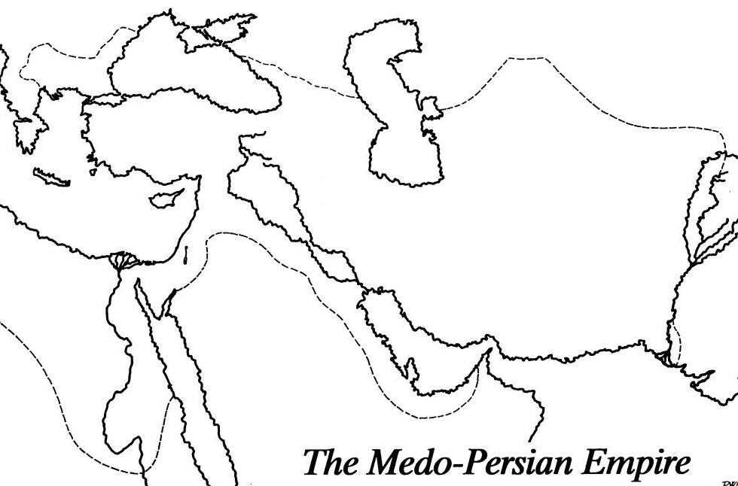

Cities  Alexandria  Persepolis  Jerusalem | Bodies of Water  Black Sea  Euphrates River  Tigris River  Caspian Sea  Indian Ocean  Mediterranean Sea  Nile River  Indus River | Regions  Asian Minor  Greece  Macedon  Persia  Egypt  Media  Mesopotamia | Misc.  Royal Road

THIRD NINE WEEKS BENCHMARK TEST MAP TWO

Cities/Regions  Athens  Sparta  Laconia  Messenia | Bodies of Water  Ionian Sea  Hellespont  Aegean Sea | Misc.  Peloponnesian League  Delian League

