UNIT MATERIALS

AP UNITED STATES GOVERNMENT AND POLITICS

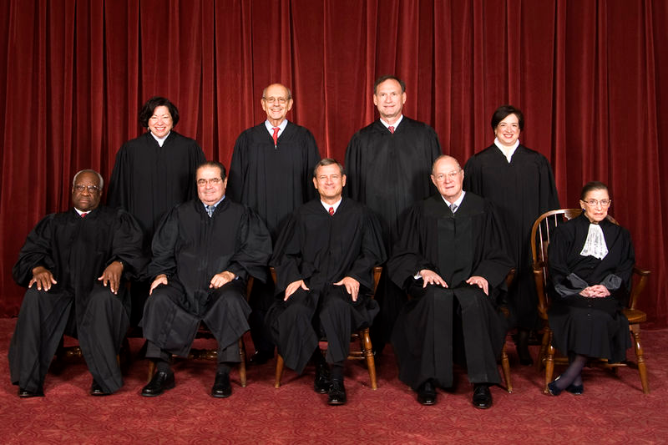

UNIT III | The Judiciary, Civil Rights,  and Civil Liberties

AP US GOVERNMENT AND POLITICS  ESSENTIAL TERMS LIST | UNIT III  The Judiciary / Civil Rights & Liberties

THE CONSTITUTION

The Bill of Rights (especially 1st, 2nd, 4th, 5th, 6th, 8th, 9th, 10th)
Fourteenth & Fifteenth Amendments
Discrimination (Race and Gender)

First Amendment Vocabulary (Establishment Clause, Free Exercise Clause, “Wall of Separation” Doctrine)
Right to Privacy (and controversies involving – namely abortion)
ACLU

THE FEDERAL JUDICIARY

Amicus curiae Brief
Stare decisis
Writ of Certiorari
Originalism (Original Intent)
Judicial Activism
Judicial Review
Selective Incorporation (Incorporation Doctrine)
The nomination and confirmation process
“Borking”
“Ginsburg Rule”
Clarence Thomas confirmation hearings
The judiciary and public opinion
Checks and Balances
Chief Justice & Associate Justices (Currently 8)
Life Tenure
The structure of the federal judiciary
(district courts, appellate courts, judicial circuits)

SUPREME COURT CASES

Tier One
(Mentioned on Multiple Released Exams)

Marbury v. Madison
Mcculloch v. Maryland
Gibbons v. Ogden
Dred Scott v. Sandford
Plessy v. Ferguson
Brown v. Board
Miranda v. Arizona
Roe v. Wade
Tier Two
(Mentioned on a Released Exam)

Baker v. Carr
Gideon V. Wainwright
Gitlow v. New York
Griswold v. Connecticut
Korematsu v. United States
Mapp v. Ohio
New York Times v. Sullivan
Shaw v. Reno
Sweatt v. Painter
Wolf v. Colorado

Tier Three
(Landmark Cases Not Mentioned on Available Exams)

Schechter Poultry Corp. v. United States
Civil Rights Acts

1957 1960
1964 1968
Heart of Atlanta Motel v. United States
Tinker v. Des Moines
Miller v. California
Hustler Magazine v. Falwell
Schenck v. United States
Texas v. Johnson
Engle v. Vitale
Lemon v. Kurtzman
Regents v. Bakke
AP US GOVERNMENT AND POLITICS
LEARNING SUPPLEMENTS

UNIT III
The Judiciary, Civil Rights & Liberties

Textbook Chapters (Click for PowerPoint)

Chapter 4 (Civil Liberties and Public Policy)
Chapter 5 (Civil Rights and Public Policy)
Chapter 16 (The Federal Courts)

Supplemental Readings

Article III – The Judicial Branch (U.S. Constitution)

The Federalist No. 78 (The Judiciary Department)
The Federalist No. 84 (Certain General and Miscellaneous Objections… Considered and Answered)

Brutus Essays ( Excerpt 1 Excerpt 2 Excerpt 3 Excerpt 4 )

Thomas Jefferson to William Jarvis (September 28, 1820)

Andrew Napolitano, The Constitution in Exile, Chapter 2 (The Rise of the Supreme Court)

William Rehnquist, The Supreme Court, Chapter 1 (Marbury v. Madison)
William Rehnquist, The Supreme Court, Chapter 11 (Presidential Appointments to the Supreme Court)
Mark Levin, Men in Black, Chapter 1 (Radicals in Robes)

William J. Watkins, Jr., “Abandon the ‘Ginsburg Rule’ for Supreme Court Candidates”
William J. Watkins, Jr., “A Role for the People in Judicial Selection”

Videos

Robert Bork Confirmation Hearings Clip 1 Clip 2 Anti-Bork Ad
Clarence Thomas Confirmation Hearings Clip 1 Clip 2 Clip 3
Ruth Bader Ginsburg Confirmation Hearings Clip 1
Samuel Alito Confirmation Hearings Clip 1

AP US GOVERNMENT AND POLITICS

SUPREME COURT CASE PROJECT

General Criteria:

Groups of 2-3 students
A 10-15 minute multimedia presentation with lasting value
(i.e., something that I can show to classes in future years)

The best presentations will combine video clips, narrations over still images, and on-screen text when necessary.

You should consider the following when researching:

- Facts of the Case (Background)
- Constitutional Questions
- Stare decisis
- Lower Court Decision(s)

- The Court’s Decision:

  - Majority Opinion
  - Concurring Opinion(s)
  - Dissenting Opinion(s)

*** NOTE: You are not required to consider all concurring or dissenting opinions, but only the ones that make significant arguments that add something to the understanding of the central constitutional questions and/or inform later decisions.

- Respect for Precedent / Activism (to what extent were each present?)
- Judicial Philosophies (originalism, textualism, activism, strict/loose construction, international law, “living constitution”)
- Public Opinion (any relevant polling data you can find – if any exists for your case)

- THE LEGACY

  - What’s happened as a result?
  - How has the ruling influenced American society?
  - How has this ruling influenced subsequent rulings?
    - Are there any “tests” that are employed now as a result of the ruling?

HELPFUL WEBSITES:
Cornell University Legal Information Institute (LII)
Landmark Cases at Street Law

TEST III WORDLE

